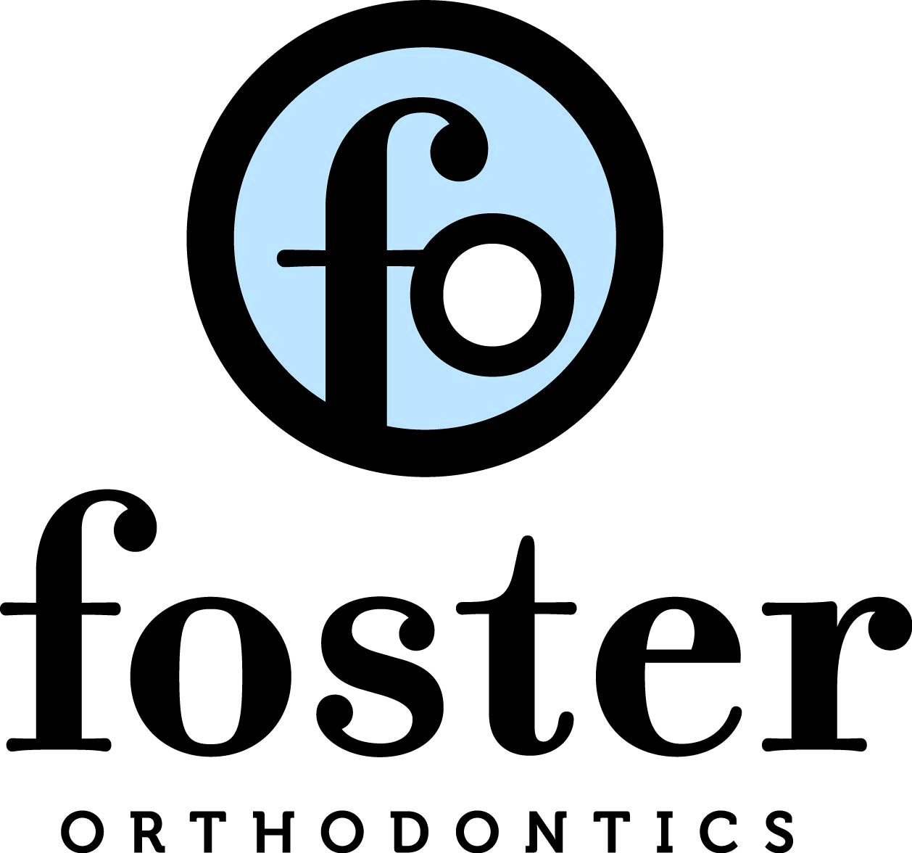
MEDICAL HISTORY DENTAL HISTORY

PLEASE CHECK IF PATIENT HAS OR HAS HAD THE FOLLOWING:

( ) ANY INJURIES TO FACE, MOUTH, OR TEETH
( ) THUMB, FINGER, SUCKING
( ) MORE THAN AVERAGE AMOUNT OF TOOTH DECAY
( ) EXTRA PERMANENT TEETH
( ) TEETH REMOVED BY EXTRACTION
( ) DIFFICULTY IN SWALLOWING OR CHEWING
( ) ANY PAIN OR CLICKING WHEN OPENING MOUTH
( ) IS PATIENT ADOPTED? AT WHAT AGE?________
( ) PREVIOUSLY CONSULTED BY ANOTHER ORTHODONTIST

(Y) (N) DOES THE PATIENT VISIT THE DENTIST REGULARLY?
DATE OF LAST VISIT____________________

ON ITEMS CHECKED, PLEASE PROVIDE A MORE DETAILED DESCRIPTION:
:__________________________________________________________________________________________________________________________________
_________________________________________________________________

PLEASE CHECK IF PATIENT HAS OR HAS HAD THE FOLLOWING
( ) JOINT SWELLING ( ) TUBERCULOUS
( ) BONE DISORDERS ( ) ANEMIA
( ) HEART TROUBLE ( ) EPLIEPSY (CONVULSIONS)
( ) MITRAL VALVE TROUBLE ( ) PROLONGED BLEEDING
( ) RHEUMATIC TROUBLE ( ) FAINTNESS
DIZZINESS
( ) DIABETES ( ) TONSILS REMOVED
( ) EMOTIONAL PROBLEMS ( ) ADENOIDS REMOVED
( ) BRAIN INJURY ( ) SORE THROAT
( ) KIDNEY/LIVER INVOLVEMENT ( ) TONSILILITIS
( ) JOINT PROSTHESIS ( ) EARACHES
( ) LATEX ALLERGY ( ) METAL/PLASTIC ALLERGY
HAVE YOU OR ANY MEMBERS
OF YOU FAMILY HAD:
(Y) (N) RHUEMATOID ARTHRISTIS
(Y) (N) LUPUS

ON ITEMS CHECKED, PLEASE PROVIDE A MORE DETAILED DESCRIPTION:
:_________________________________________________________________________________________________________________________________________________________________________________

IS PATIENT PRESENTLY UNDER PHYSICIAN CARE FOR ANY REASON?

_____________________________________________________________

NAME OF PRIMARY PHYSICIAN__________________________________

LIST ANY OTHER SERIOUS ILLNESSES

___________________________________________________________

LIST DRUGS OR MEDICATIONS BEING TAKEN:____________________________________________________________________________________________________________________________

DO YOU TAK ANY MEDICATIONS FOR OESTEOPOROSIS?
IF YES, PLEASE LIST:________________________________________________
LIST ANY ALLERGIES:_______________________________________________
________________________________________________________________

WE ARE UNABLE TO ACCEPT DIVORCE DECREES AS ASSIGNENTS OF RESPONSIBILITY FOR A CHILD’S ORTHODONTIC BILLS. THE PARENT ACCOMPANYING THE CHILD SHOULD PAY FOR THE SEVICES AND SEED ANY REIMBURSEMENT FOR THE OTHER PARENT. TO THE BEST OF MY KNOWLEDGE, THE ABOVE INFORMATION IS COMPLETE AND CORRECT. I GIVE MY PERMISSION FOR ANY PHOTOGRAPHS, X-RAYS, OR STUDY MODELS TO BE USED FOR THE DISPLAYS AT SCIENTIFIC MEETINGS, PRESENTATION, AND PUBLICATION OF A SCIENTIFIC NATURE OR FOR STUDY GROUP PURPOSES TO FURTHER THE ART AND SCIENCE OF ORTHODONTICS. I, THE UNDERSIGNED, AGREE TO PAY FOR ATTORNEY FEES AND TOEHR COSTS OF COLLECTIONS IN THE EVENT IT BECOMES NECESSARY TO USE ATTORNEY SERVICES TO SECURE PAYMENT OF THIS ACCOUNT.
Signature:_______________________________________________________________________________________Date:_____________________________________

